Doing things right or doing the right things? Management v Leadership.

You are a lawyer. That’s what you trained to do, and that’s your passion. You enjoy the challenge of using your understanding of the law to get the best outcomes for your clients. You want to be recognised for your legal expertise. Your many years of training and professional qualifications have led to this.

But you’re more than that. Because you’re a good lawyer, you have become, or expect to become a partner in your firm. Maybe you are the senior partner, or the managing partner. You are, or will be, an accidental businessperson. Your many years of training and professional qualifications did nothing to prepare you for this.

This is the reason why Eurojuris International created the Management Group some years ago – to give a space for those with responsibilities managing their law firm to share ideas and best practice. When Simon Gittings joined the Eurojuris International Board I agreed to take over as chair of this group, and we’ve had some interesting meetings over the years.

But increasingly I find I have a problem with the word ‘management’. It can mean different things to different people, and over the years I have found that when I say ‘management’ to lawyers, sometimes what they hear is ‘administration’. And believe me, that’s a word that has little or no resonance or attraction to lawyers.

The late US academic and writer Warren G Bennis is recognised as the authority on business leadership, and the differences between that and management. Successful business leaders often combine some of these characteristics, but below is a summary of his assessment of the main differences between leaders and managers.

Working on the business rather than in the business, focusing on culture, developing, nurturing and empowering team members and being a champion for change are all differentiators, and we all saw plenty of examples of this during the emergency phase of the pandemic when the usual rules were suspended, and we had to find new ways of working.

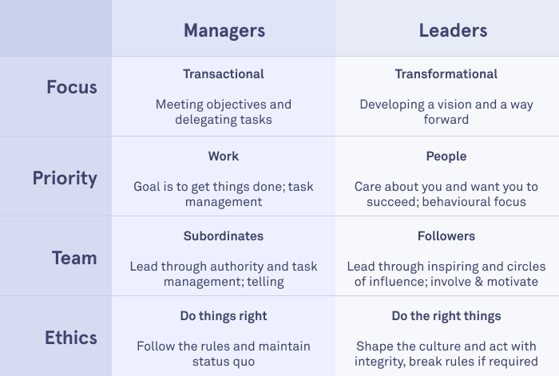

Every business needs sound administration and efficient managers. But the best businesses will always be those that benefit from good leadership.

From January 2023, the re-named Leadership Group will help all of you with leadership responsibilities, either for a team, a practice area, or your whole firm, to meet, explore ideas and share experiences. We’ll have a mix of academic input, workshops, discussions, case studies and external speakers from the legal sector and elsewhere. We will meet face-to-face at Practice Days and at Congress, and if there is an appetite for it, we’ll have online sessions in between.

Watch this space for an announcement about our content at the Practice Days next May in Antwerp, but meanwhile we’re planning an online meeting in January featuring a speech on leadership techniques from a leading UK business school academic, followed by a group discussion.

Watch this space!

Chris Marston, Chair, Eurojuris International Leadership Group

Chris Marston is the Chief Executive of LawNet, a network of more than 70 law firms in the UK & Ireland, comprising more than 2,500 lawyers and over £350m of annual fees. Chris speaks and writes regularly on law firm leadership, management and finance issues, and was previously UK Head of Professional Practices at Lloyds Bank. He has a Post Graduate Certificate in Legal Practice Management from Manchester Metropolitan University.

